Linear regression:

1. Definition of Linear regression
2. Linear regression formulae
3. Simple and multiple linear regression
4. Goal: Identify suitable coeff in order reduce the error
5. Error - SSE – MSE – RMSE
6. Loss and Cost
7. We find coeff formulae , OLS
8. Interpretation
9. What is the meaning of bo and b1
10. RSE : average deviation from true regression line

$R S E=\sqrt{\frac{RSS}{n-2}}$

$RSS=\sum_{i=1}^{n}{}{\left(y_{actual_{i}}-y_{prdicted_{i}}\right)}^{2}$

$RSE is talking error about interms formulae$

$error is a negative vibration$

$Lack of fit$

$How good our line is passing through actual observations,$

$RSE will tell about how much the line is lack====lack of fit$

$RSE will talk only about outputs , actual vs predictions$

$It will never discuss about inputs$

$R-squared :$

$y_{actual_{i}}$

$y_{prdicted_{i}}=b_{0}+b_{1}x1+b_{2}x2$

$y_{average}==== > base$

$> y=tv+np+sm$

${\hat{y}}_{i}=model predictions, y_{i}=actual output, {\underline{y}}_{i}=average actual output value$

$SS_{Total}=SS_{Residuals}+SS_{Explained}$

$SS_{Total}=Total Sum of squares$

$SS_{Residuals}=Residual sum of squares$

$SS_{Explained}=Explained sum of squares$

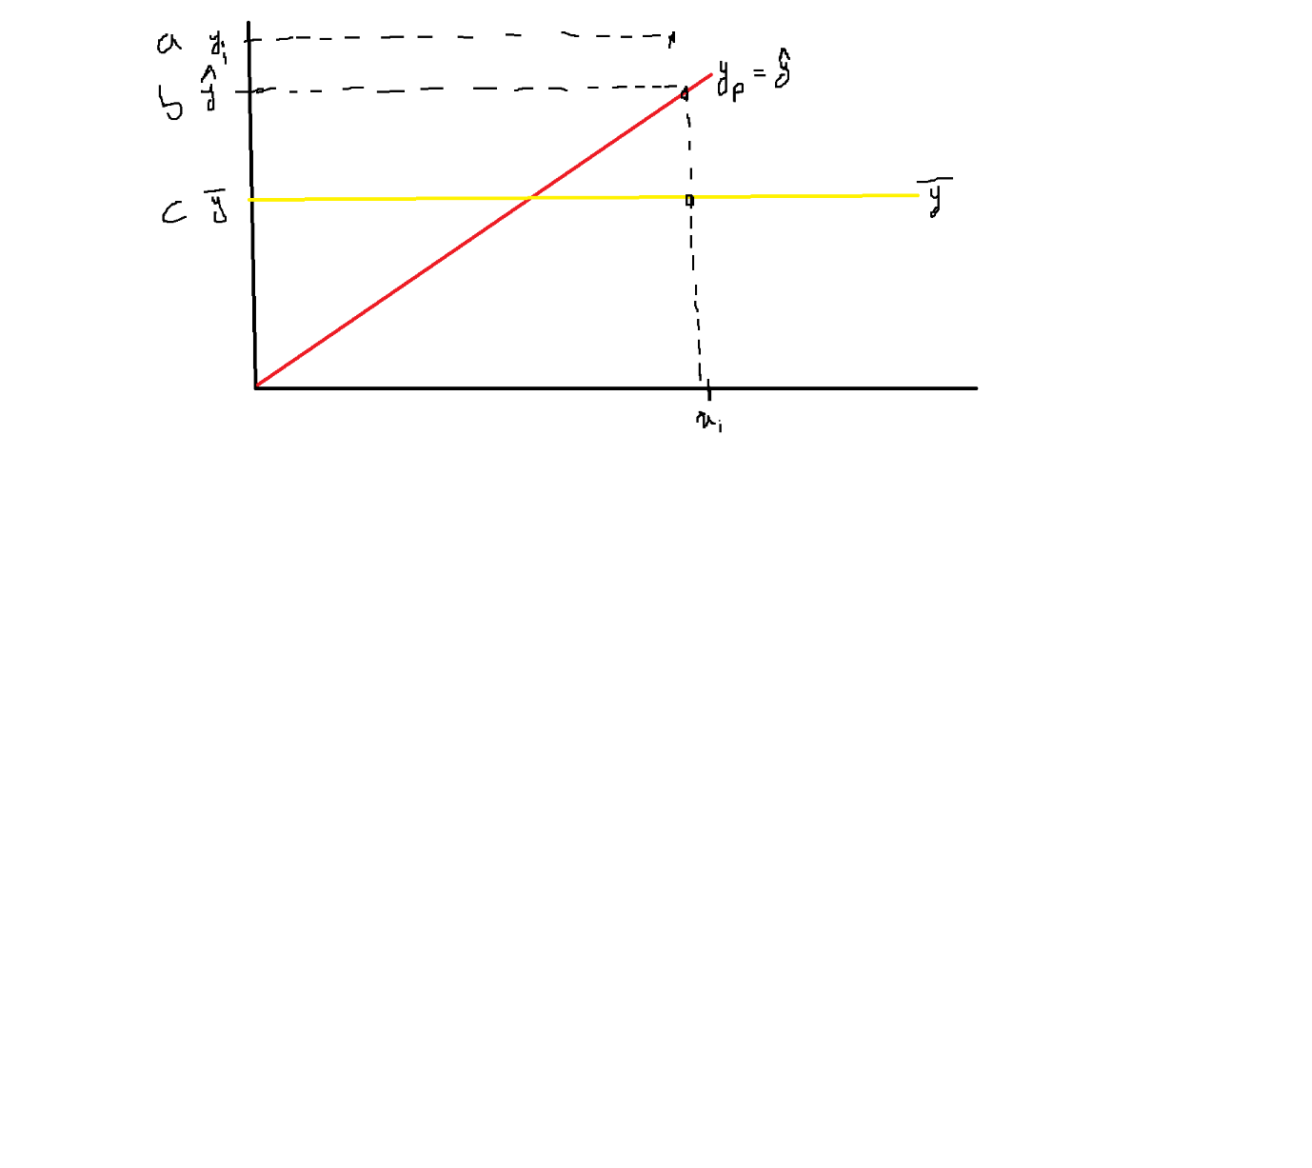

$\sum_{i=1}^{n}{}{\left(y_{i}-\underline{y}\right)}^{2}=\sum_{i=1}^{n}{}{\left(y_{i}-{\hat{y}}_{i}\right)}^{2}+\sum_{i=1}^{n}{}{\left({\hat{y}}_{i}-\underline{y}\right)}^{2}$

${\hat{y}}_{i}-\underline{y}=explained error after LR and average value$

$SS_{Total}=SS_{Residuals}+SS_{Explained}$

$SS_{Total}/SS_{Total}=SS_{Residuals}/SS_{Total}+SS_{Explained}/SS_{Total}$

$1=\frac{SS_{Residuals}}{SS_{Total}}+\frac{SS_{Explained}}{SS_{Total}}$

$\frac{SS_{Explained}}{SS_{Total}}=1-\frac{SS_{Residuals}}{SS_{Total}}$

$R-squared=1-\frac{SS_{Residuals}}{SS_{Total}}$

$R-squared=1-\frac{sum of squared residuals \left(SSR\right)}{Total sum of squares\left(SST\right)}$

$R-squared=1-\frac{\sum_{i=1}^{n}{}{\left(y_{i}-{\hat{y}}_{i}\right)}^{2}}{\sum_{i=1}^{n}{}{\left(y_{i}-\underline{y}\right)}^{2}}$

$Coefficient of determination will tell about explainaibity of y$

$R-squared will provide how much target variable explained by input variables$

$R-squared min=0 , R-squared max=1$

$assume R-squared=0.7,$

$input variables explained about output variables with 70\%$

$70\% of variation in output is explained about input$

$sales=b_{0}+b_{1}*TV+b_{2}*SM$

$idenify the coeff, we got the line, r-squared=0.8$

$TV and SM explain about Sales with 80\%$

$80\% variation in sales explained by TV and and SM$

$Good ness of fit$

| X | Y ${=y}_{i}$ | Y_p= ${\hat{y}}_{i}=$ 0.143+1.229x | Residual $y_{i}-{\hat{y}}_{i}$ | Square of residual ${(y}_{i}-{\hat{y}}_{i})^2$ | $\underline{y}$ | $y_{i}-\underline{y}$ | ${(y}_{i}-\underline{y})^2$ |
| --- | --- | --- | --- | --- | --- | --- | --- |
| 2 | 2 | 2.601 | 2-2.601=-0.601 | 0.361201 | 4.75 | 2-4.75=-2.75 | 7.5645 |
| 3 | 4 | 3.83 | 4-3.83=0.17 | 0.0289 | 4.75 | 4-4.75=-0.75 | 0.5625 |
| 4 | 6 | 5.059 | 6-5.059=0.941 | 0.885481 | 4.75 | 6-4.75=1.25 | 1.5625 |
| 6 | 7 | 7.517 | 7-7.517=-0.517 | 0.2672 | 4.75 | 7-4.75=2.25 | 5.0625 |
|  |  |  | SSR= | 1.542871 |  |  | 14.75 |

$\sum_{i=1}^{n}{}{\left(y_{i}-{\hat{y}}_{i}\right)}^{2}=1.542871$

$\sum_{i=1}^{n}{}{\left(y_{i}-\underline{y}\right)}^{2}=14.75$

$R-squared=1-\frac{1.542871}{14.75}=0.8954$

$89.5\% variation in output can explained by input$

$R-squared=1-\frac{\sum_{i=1}^{n}{}{\left(y_{i}-{\hat{y}}_{i}\right)}^{2}}{\sum_{i=1}^{n}{}{\left(y_{i}-\underline{y}\right)}^{2}}$

$\sum_{i=1}^{n}{}{\left(y_{i}-{\hat{y}}_{i}\right)}^{2}=0====== >R-squared=100$

$No model will give 100\% accuracte$

$if you get errot is zero or model accuracy is 100\% , overfitting$

$R-square value keep on increasing when you add more variable$

$Example:2 input variable x_{1}, x_{2}==== >R-square=0.75$

$3 input variable x_{1}, x_{2},x_{3}==== >R-square=0.85$

$4 input variable x_{1}, x_{2},x_{3},x_{4}==== >R-square=0.95$

$Sourav thinks more r-square my model is good$

$he has 100 input variables, he used all 100=====R-square=100\%$

$he felt very hapy, then he wants to test his model$

$then he pass the test data======it gives wired output$

$when you are training the model train data=====train errore very very less$

$when you apply the test data=====test error very very huge$